18th ANNUAL GATHERING OF SHELLFISH COMMISSIONS

Saturday, April 2, 2022, 9:00 a.m. to 1:00 p.m.

Connecticut Agricultural Experiment Station, Auditorium
123 Huntington Street, New Haven, CT 06511

The Connecticut Sea Grant Extension Program hosts this event with support from the Connecticut Department of Agriculture. The purpose of this program is to improve shellfisheries management by providing educational resources and tools that allow commission members to make informed, science-based decisions regarding recreational and commercial shellfisheries. Thank you for your participation!

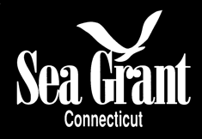 | 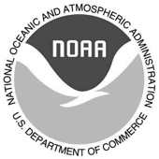 | 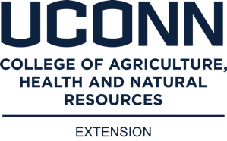 | 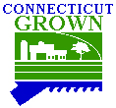

AGENDA
9:00 a.m. Welcome
Tessa Getchis, Extension Educator, Connecticut Sea Grant/UConn Extension

9:05 Introductions to DA/BA Staff
David Carey, Director, CT Department of Agriculture, Bureau of Aquaculture (CT DOAG BA)

9:10 Hazardous Algal Bloom and Shellfish Disease Status Review
Emily Marquis, Fisheries Biologist 1, CT DOAG BA

9:30 Water Sampling Collection Procedures
Alissa Dragan, Supervising Environmental Analyst 3, CT DOAG BA

9:50 Shellfish Restoration Guide & Surveys of Natural Oyster Habitat
Tessa Getchis, Extension Educator, Connecticut Sea Grant/UConn Extension

10:10 Break

10:20 Natural bed enhancement efforts
David Carey, Director, CT Department of Agriculture, Bureau of Aquaculture

10:40 Pump Out Boat Programs
Kate Brown, BIG/CVA Program Coordinator, Boating Division, Outdoor Recreation CT DEEP
& Alissa Dragan, Supervising Environmental Analyst 3, CT DOAG BA

11:00 LIS Coastal Zone Soil Survey
Debbie Surabian, USDA Natural Resources Conservation Service CT Office

11:30 Commission Roundtable and Refreshments

1:00 p.m. Closing Remarks

